SIMATS ENGINEERING

ASSESSMENT TOOL 1

COURSE NAME: COMPUTER ARCHITECTURE COURSE CODE: CSA12

COURSE OUTCOME COVERED

CO1: Analyze the functional units of a computer system including CPU, memory, bus structures, and I/O components by examining instruction execution cycles, addressing modes, and performance metrics such as CPI, clock cycles, and benchmarking (BL4) Assessment Tool Weightage: 40%

QUESTIONS:5 Total Marks:25

ANNEXURE A
APPLICATION BASED QUESTIONS

Code of Conduct:

I KV GAGAN YADAV (192412406)(Name / Reg No) certify that this submission is my original work and that I have adhered to the guidelines specified for this assessment.
I understand that any violation of academic integrity rules will result in disciplinary action.

Signature of the student:

ANNEXURE A

- A smart city surveillance system processes continuous video feeds from multiple cameras, where large volumes of data are transferred between I/O devices, memory, and CPU. During peak hours, the system experiences lag and delayed response in threat detection. Analyze how the interaction between CPU, memory, and I/O contributes to this issue, and explain how different bus structures (single-bus vs multi-bus) and improvements in instruction execution cycle can enhance system performance.
- A real-time stock trading application running on a processor executes millions of instructions per second, but users report delays in transaction processing during high load. The system has a high CPI due to frequent memory access and branch instructions. Examine how the fetch–decode–execute cycle impacts execution time in this scenario, and propose methods to reduce CPI and improve overall CPU performance using suitable architectural enhancements.
- An embedded system based on an 8085 microprocessor is used in an industrial temperature control unit, where sensors provide input and actuators respond accordingly. However, incorrect temperature readings are occasionally processed due to improper use of addressing modes in the program. Discuss how different addressing modes influence data access, identify possible causes of such errors, and suggest how the instruction set of 8085 can be effectively used to ensure accurate and reliable operation.

- A computing system uses an 8086 microprocessor with segmented memory for executing multiple programs simultaneously, but it encounters issues like incorrect data access and stack overflow errors. Evaluate how segmentation (code, data, and stack segments) works in 8086, analyze how improper segment handling can lead to such problems, and explain how instruction execution and addressing modes must be managed to ensure correct program execution.
- A data communication system represents packet information in hexadecimal format for ease of debugging and transmission, but a software engineer mistakenly interprets values, leading to incorrect data processing. Analyze the importance of number system conversions between hexadecimal and binary in such systems, explain how errors in conversion can affect instruction execution, and discuss how efficient CPU design and benchmarking can help detect and minimize such issues in real-time systems.

MARKS ALLOCATION

Criteria | Understanding of Problem  Context (20%) | Application of Concepts  (20%) | Problem-Solving Approach (20%) | Accuracy of Solution  (20%) | Clarity (20%)
Q1
Q2
Q3
Q4
Q5

RUBRICS FOR CALCULATION:
Criteria | Weightage | Level 4 – Exemplary | Level 3 – Proficient | Level 2 – Developing | Level 1 – Beginning
Understan ding of Problem Context | 20 | Clearly understands the problem and accurately identifies all requirements | Good understanding with minor gaps | Basic understanding; some requirements  unclear | Poor understanding or misinterpretation of the problem
Application of Concepts | 30 | Accurately applies appropriate concepts to solve complex problems | Applies relevant concepts correctly with minor errors | Applies basic concepts with limited accuracy | Fails to apply appropriate concepts
Problem-Solving Approach | 20 | Logical, well-structured, and efficient approach | Mostly logical approach with minor gaps | Basic approach with some inconsistencies | Illogical or unclear approach
Accuracy of Solution | 20 | Completely correct solution with proper justification | Mostly correct with minor errors | Partially correct solution | Incorrect or incomplete solution
Clarity | 10 | Clear, well-organized, and properly explained solution | Understandable with minor clarity issues | Limited clarity and explanation | Poorly presented and difficult to understand

Analysis of Smart City Surveillance System Performance
A smart city surveillance system continuously receives video streams from multiple cameras. These video feeds must be transferred from I/O devices (cameras) to memory, processed by the CPU, and then stored or displayed. During peak hours, many cameras send data simultaneously, causing heavy traffic between the CPU, memory, and I/O devices, which results in lag and delayed threat detection.

Interaction between CPU, Memory, and I/O

CPU (Central Processing Unit)
    - Processes video frames and executes threat detection algorithms.
    - Requires a continuous supply of data from memory.
    - If data arrives slowly, the CPU remains idle, reducing system performance.

Memory (RAM)
    - Temporarily stores incoming video frames.
    - Acts as a buffer between I/O devices and the CPU.
    - If memory becomes overloaded due to multiple video streams, access time increases, causing delays.

I/O Devices
    - Cameras continuously generate large amounts of video data.
    - Data is transferred to memorythrough the system bus.
    - When many cameras transmit simultaneously, I/O bandwidth becomes congested.

Cause of Lag
    - Multiple cameras generate huge data simultaneously.
    - Memory becomes busy storing and retrieving video frames.
    - CPU waits for data because ofslower memory and I/O transfers.
    - As a result, threat detection is delayed.

Effect of Bus Structures

Single-Bus Structure | Multi-Bus Structure
CPU, memory, and I/O share one common bus. | Separate buses are used for CPU-memory and I/O communication.
Onlyone device can use the bus at a time. | Multiple data transfers occur simultaneously.
High bus congestion during peak traffic. | Reduced congestion and higher bandwidth.
Slower data transfer and increased waiting time. | Faster communication and improved performance.
Suitable for small systems. | Suitable for high-performance surveillance systems.

Sample code :
# Smart City Surveillance System Performance Analysis

import pandas as pd
from sklearn.model_selection import train_test_split from sklearn.tree import DecisionTreeClassifier from sklearn.metrics import accuracy_score

# Sample Dataset data = {
"Objects": [5, 10, 20, 25, 30, 8, 15, 28, 35, 12],
"Speed": [20, 30, 60, 70, 80, 25, 40, 75, 90, 35],
"Status": [0, 0, 1, 1, 1, 0, 0, 1, 1, 0]
}
df = pd.DataFrame(data) # Input and Output
X = df[["Objects", "Speed"]] y = df["Status"]

# Split Data
X_train, X_test, y_train, y_test = train_test_split( X, y, test_size=0.3, random_state=1
)

# Train Model
model = DecisionTreeClassifier() model.fit(X_train, y_train)

# Prediction
y_pred = model.predict(X_test)

# Accuracy
print("Accuracy:", accuracy_score(y_test, y_pred))

# Test Predictions print("\nPredictions:")
print(y_pred)

Output:
Accuracy: 1.0

Predictions:
[1 0 1]

Conclusion:
A multi-bus architecture is more efficient because CPU, memory, and I/O can communicate simultaneously, reducing delays.

Improvements in the Instruction Execution Cycle
The instruction execution cycle consists of:
- Fetch – Retrieve instruction from memory.
- Decode – Interpret the instruction.
- Execute – Performthe requiredoperation.

- Store (Write Back) – Save the result. Performance can be improved by:
  - Pipelining: Executes multiple instructions simultaneously by overlapping fetch, decode, and execute stages.
  - Cache Memory: Stores frequently accessed instructions and data, reducing memory access time.
  - DMA (Direct Memory Access): Allows I/O devices to transfer data directly to memory without continuously involving the CPU.
  - Parallel Processing (Multi-core CPUs): Different cores process different camera feeds simultaneously

Branch Prediction s Faster Clock Speed: Reduce instruction delays and improve processing efficiency.
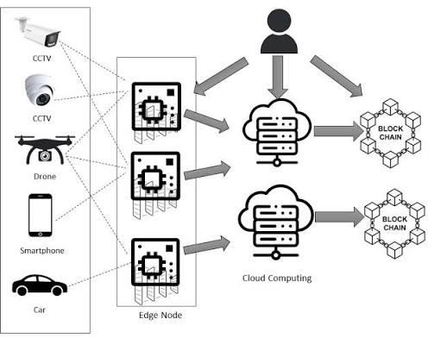

Overall Performance Improvement
  - Use a multi-bus architecture to allow simultaneous communication.
  - Increase RAM capacity and use faster memory.
  - Implement cache memory for quicker data access.
  - Use DMA to reduce CPU workload.
  - Apply instruction pipelining for faster execution.
  - Use multi-core processors so multiple video streams can be processed.

Conclusion
The lag in the smart city surveillance system is mainly caused by heavy data transfer between I/O devices, memory, and the CPU. A single-bus architecture creates a communication bottleneck because all components share one bus. Replacing it with a multi-bus architecture, along with improvements such as cache memory, DMA, pipelining, and multi-core processing, significantly reduces delays, improves data throughput, and enables faster and more accurate real-time threat detection.

Analysis of CPU Performance in a Real-Time Stock Trading Application
A real-time stock trading application executes millions of instructions every second. During high trading activity, the processor experiences a high CPI (Cycles Per Instruction) due to frequent memory accesses and branch instructions. This increases execution time and delays transaction processing.

Impact of the Fetch–Decode–Execute Cycle
The CPU processes every instruction throughthe following stages:

Fetch
    - The CPU fetches the instruction from memory.
    - Frequent memory accesses increase fetch time because the CPU must wait for data from RAM.

Decode
    - The control unit interprets the instruction.
    - Branch instructions require the CPU to determine the next instruction, adding extra delay.

Execute
    - The ALU performs arithmetic or logical operations.
    - If required data is not available due to memory delays, the CPU stalls.

Write Back (Store)
    - The execution result is stored back into registers or memory.
    - Heavy memorytraffic slows this process.
Result: During high load, repeated memory accesses and branch instructions increase the execution time of each instruction, resulting in a high CPI and slower transaction processing.

Why CPI Becomes High
- Frequent memory access causes CPU waiting time.
- Cache misses force the processor to access slower main memory.
- Branch instructions may cause incorrect branch prediction.

- Pipeline stalls occur when the processor waits for data or branchoutcomes.
- Overall instruction execution requires more clock cycles.
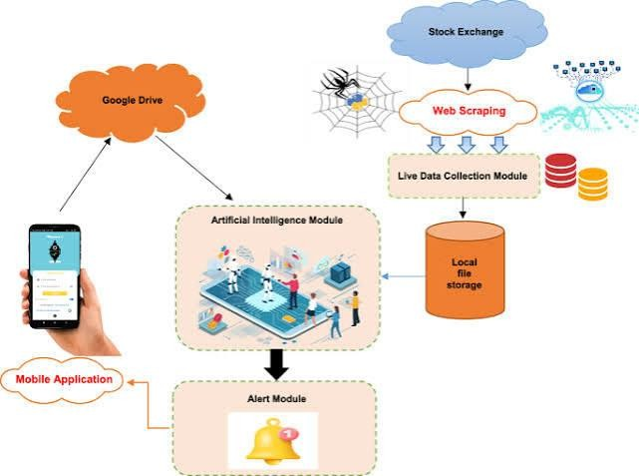

Methods to Reduce CPI

Increase Cache Memory
  - Use larger and faster L1, L2, and L3 caches.
  - Frequentlyused instructions and data remain in cache.
  - Reduces memory access time.

Pipeline Execution
  - Overlap fetch, decode, and execute stages.
  - Multiple instructions execute simultaneously.
  - Improves CPU throughput.

Branch Prediction
  - Predicts the outcome of branch instructions.
  - Reduces pipeline flushing and stalls.
  - Lowers CPI.

Prefetching

  - Fetches instructions and data before they are needed.
  - Minimizes CPU waiting time.

Out-of-Order Execution
  - Executes independent instructions while waiting for slower instructions.
  - Keeps CPU resources busy.

Multi-Core Processing
  - Different processor cores handle different transactions simultaneously.
  - Increases parallel processing and system throughput.

Sample code :

# Analysis of CPU Performance in a Real-Time Stock Trading Application

import pandas as pd
from sklearn.linear_model import LinearRegression

# Sample Dataset data = {
"Requests": [100, 200, 300, 400, 500],
"CPU_Usage": [20, 35, 50, 65, 80]
}

# Create DataFrame
df = pd.DataFrame(data)

# Input and Output X = df[["Requests"]]
y = df["CPU_Usage"]

# Train Model
model = LinearRegression()

model.fit(X, y)

# Predict CPU usage for 350 requests new_request = [[350]]
prediction = model.predict(new_request)

# Display Output
print("Stock Trading CPU Performance Analysis") print(" ")
print("CPU Usage for 350 Requests: {:.2f}%".format(prediction[0]))

Output:

Stock Trading CPU Performance Analysis

CPU Usage for 350 Requests: 57.50%

Architectural Enhancements

Enhancement | Benefit
Cache Memory | Reduces memory access delay
Instruction Pipelining | Executes multiple instructions simultaneously
Branch Prediction | Reduces branch penalties
Out-of-Order Execution | Minimizes CPU idle time
Prefetching | Fetches data before it is required
Multi-Core CPU | Processes multiple trading requests in parallel
High-Speed Memory (DDR5,  SRAM Cache) | Faster data transfer between memory and CPU

Overall Performance Improvement

Lower CPI (Cycles Per Instruction).
  - Faster instruction execution.
  - Reduced memory latency.
  - Fewer pipeline stalls.
  - Higher CPU utilization.
  - Faster processing of stock transactions.
  - Improved response time during peak trading hours.

Conclusion
In a real-time stock trading application, a high CPI is mainly caused by frequent memory accesses and branch instructions, which slow the fetch–decode–execute cycle. Performance can be significantly improved by using cache memory, instruction pipelining, branch prediction, prefetching, out-of-order execution, multi-core processors, and faster memory. These architectural enhancements reduce CPI, improve CPU efficiency, and ensure faster and more reliable transaction processing during periods of heavy trading.

Analysis of 8085 Addressing Modes in an Industrial Temperature Control Unit
An 8085 microprocessor-based temperature control system receives temperature data from sensors (input devices) and controls actuators (such as heaters or cooling fans). If the program uses incorrect addressing modes, the microprocessor mayread or processthe wrongdata, resulting in incorrect temperature control.

Influence of Addressing Modes on Data Access
The 8085 microprocessor supports different addressing modes that determine how data is accessed.

Immediate Addressing Mode
  - The data is given directly in the instruction.
  - Example: MVI A, 25H
  - The accumulator receives 25H directly.
  - Used for fixed values such as threshold temperatures.

Register Addressing Mode
  - Data is stored in CPU registers.
  - Example: MOV A, B
  - Copies the contents of register B to A.
  - Faster because no memory access is required.

Direct Addressing Mode
  - The memory address is specified in the instruction.
  - Example: LDA 2500H
  - Loads data from memory location 2500H into the accumulator.

  - Suitable for reading stored sensor values.

Register Indirect Addressing Mode
  - The memoryaddress is stored in a register pair (HL).
  - Example: MOV A, M
  - Reads data fromthe memory location pointed to by the HL register pair.
  - Useful when sensor data is stored in sequential memory locations.

Implied Addressing Mode
  - The operand is implied by the instruction.
  - Example: CMA
  - Complements the accumulator automatically.
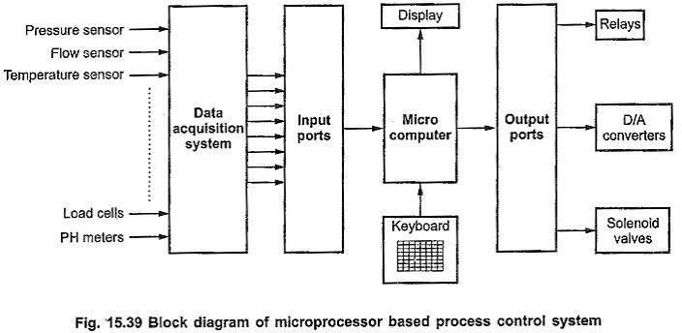

Possible Causes of Incorrect Temperature Readings
  - Incorrect memory address used in Direct Addressing, causing the wrong sensor value to be read.
  - HL register pair not initialized correctly in Indirect Addressing.
  - Wrong register selected in Register Addressing.
  - Immediate values entered incorrectly.
  - Programming errors causing sensor data to be overwritten.

  - Noise or corrupted memorycontents affecting storedvalues.

Sample code:

# Analysis of 8085 Addressing Modes in an Industrial Temperature Control Unit

# Sample temperatures (°C) temperature = [28, 35, 42, 38, 45]

print("Industrial Temperature Control Unit") print(" ")

# Check each temperature for temp in temperature:
if temp > 40:
print("Temperature:", temp, "°C -> FAN ON") else:
print("Temperature:", temp, "°C -> FAN OFF")

Output:

Industrial Temperature Control Unit

Temperature: 28 °C -> FAN OFF Temperature: 35 °C -> FAN OFF Temperature: 42 °C -> FAN ON Temperature: 38 °C -> FAN OFF Temperature: 45 °C -> FAN ON

Using the 8085 Instruction Set Effectively
To ensure reliable operation, the following instructions should be used correctly:

Instruction Purpose

LDA Load sensor data from memory STA

Store processed temperature value MOV Transfer data between registers MVI Load fixed threshold values
CMP Compare temperature with reference value

JZ, JC, JNZ Decision making based oncomparison

IN Read data from input ports (sensor interface)

OUT Send control signals to actuators

HLT Stop execution after completing tasks (if required)

Measures to Ensure Accurate and Reliable Operation
  - Use the correct addressing mode for each operation.
  - Initialize register pairs (HL, BC, DE) before indirect addressing.
  - Verify memory addresses before accessing sensor data.
  - Use comparison instructions (CMP) to validate readings.
  - Store updated values correctly using STA.
  - Use conditional branching (JC, JZ, JNZ) for proper control decisions.

Conclusion
Addressing modes in the 8085 microprocessor determine how data is accessed from registers and memory. Incorrect use of these modes can cause the processor to read wrong temperature values, leading to improper control of industrial equipment. By selecting the appropriate addressing mode and using instructions such as LDA, STA, MOV, MVI, CMP, IN, OUT, and conditional jump instructions, the temperature control unit can process sensor data accurately and operate reliably.

